Warfront

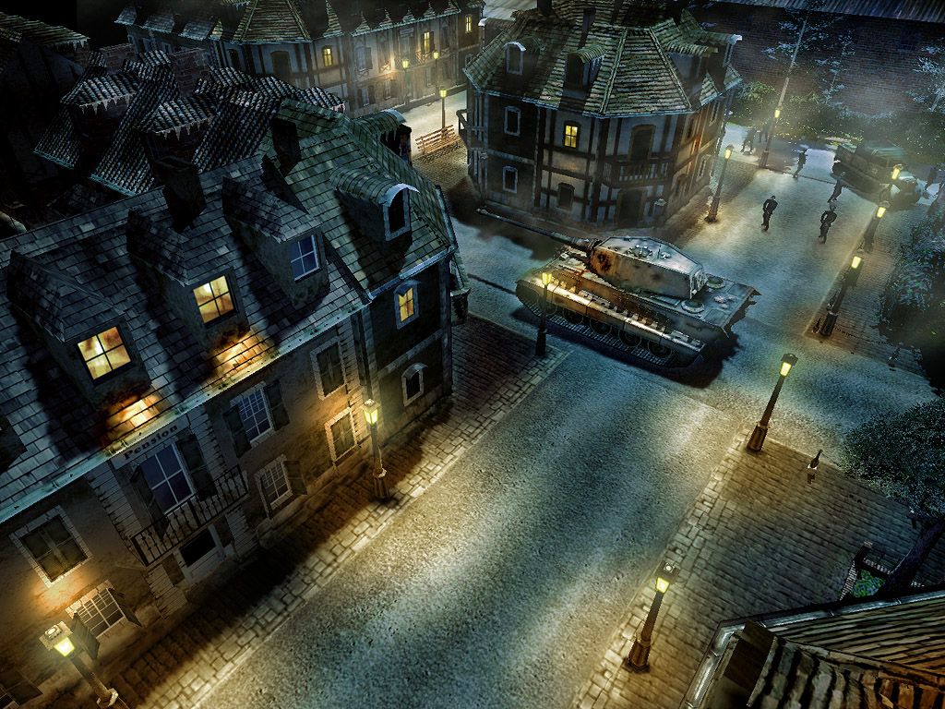

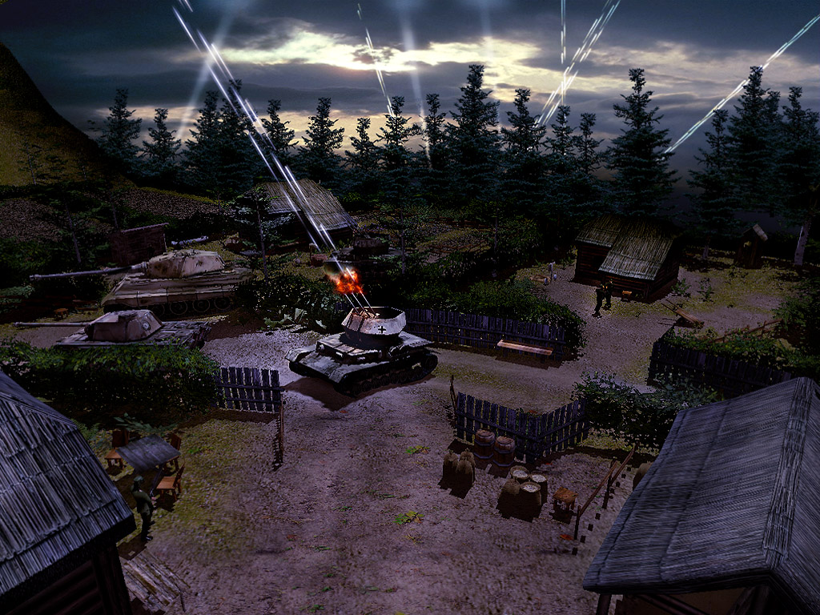
Name: Warfront
Genre: RTS
Setting: World War II

Story:

Warfront is a top of the art WWII 3D RTS game – a fast-paced, adrenaline pumping game of conquest and command. While aware of the limitations of the historical era, in gameplay it will be as close as possible to classic RTS titles like Starcraft, Warcraft3 and C&C Generals. The game will be very easy to pick up and play, uses standard RTS conventions. Players can feel the atmosphere of WW2 in a new environment: besides commanding their existing units, they have to care about reinforcement (by gathering resources on the battlefield) and research new prototypes as well. These new options amended with the possibility of direct unit control will make the difference compared to other games and provide fun playing WF.
The game is set after what Churchill described as the beginning of the end: the Allied victory in North Africa.
Choose what missions to fight, what troops to use, and when to call in reinforcements. Completing objectives and capturing strategic locations like train stations or airfields in each mission will help you to win next missions. Each mission has multiple primary and secondary objectives that are connected to other missions, to provide almost limitless strategic choices.
It shall be underlined that Warfront shall be definitely not a ‘historic Simulation’. WF shall be a game with first priority a ‘FUN – GAME’ with ‘Hollywood-Style’ and with lower priority historical correct.
The game will visually design with strong colors. Effects and Explosions will be slightly excessively designed. The game must be full of cliché’s. The Story will not be designed as a Drama.

The game is aimed to be a top-of-the-art product which has to have unique and great design features. The game must be better than every competitive product which will be released and had been released at the same time.

Features:

- USP: Realistic night mission feeling and visualization. The night will not be simply made with Textures it must be made with dynamic lights. This USP must implicate at least the following details:
  - Tracer ammo
  - Dynamic lights
  - Flares which enlighten the dark
  - Dynamic Day Night changing
  - Light must have an impact on the gameplay, means that also the line of sight switches between at least 2 sets one for light and one for dark.
  - AA-spotlights
  - “Light-Trees” (don’t know the original word) which bombers first throw out to enlighten the ground.
  - Houses must have lights in their windows.
  - Generally there have to be lots of particle effects
  - Torches
  - 20%-25% of the Missions must be Nightmissions
  - The Night must have a strongly impact on Missiondesign -progress and Gameplay.

- USP - Different Gameplay of the three Parties. Every party will have their own complete techtree, upgrades, constructible buildings and units. They will all have their unique bonuses and weaknesses and will offer different gamestyle. For example the Allies will have air superiority, Germans will have the technological edge (especially with tanks) and Russian will have some cheap units, which can be used in masses.

- USP - 3D Units with physically Details. All units are 3D animated models. There have to be physically animated detail objects added on tank-units to get a top of the art WW2 game in 2006: For example a shovel, petrol can, animated exhaust-pipe, antenna, a hatch that opens and a tank-commander is scanning the area and giving commands, acting with his arms. There are not many units in this game so they must have a very good quality. There will be Tankmodels with animated camouflage net which is placed on the tank (not just a camouflage texture!) to have some contrast within the same army.

- USP - Score System. After every Mission there will be a score calculated on a table on the screen and also added to the Profile of the player. The score will be connected to the award system and give results for the laddersystems. This will be figured out in details in the design document on basis of Appendix Statistics, smaller changes can be made as the game development progresses.

- USP - Single Player Ladder. There will be an option to load the highest scores to a ladder-like database programmed with Gamespy. As an extra the player will be able to send a full camera recording (this recording option is available in the game) to prove how you achieved this score.

(DR provides data in order to make the above listed features possible. DR is also responsible for data transmission, but this can be done only after the 3rd service-provider for ladder is selected and the rule of data transmission (source code, protocol) is delivered by the service-provider. DR will cooperate directly with the 3rd-party service-provider concerning technical issues, so that bugs and problems will be solved without major delays.)

- USP - Multiplayer-Laddersystem. WF will provide a multiplayer laddersystem with at least all classical features for example
  - Counting wins and losses for each player
  - Winning streaks (consecutive wins)
  - Percentage of wins/losses are also calculated
  - titles (awards) for the players
  - Special awards
  - Disconnected players will get a loss after a time limit. This Feature is very important and must work properly!
  - In non-ladder games human-players will be substituted by AI-Players if they disconnected.
(DR provides data in order to make the above listed features possible. DR is also responsible for data transmission, but this can be done only after the 3rd service-provider for ladder is selected and the rule of data transmission (source code, protocol) is delivered by the service-provider. DR will cooperate directly with the 3rd-party service-provider concerning technical issues, so that bugs and problems will be solved without major delays.)

- USP - Award System. Independently from the score and statistics in single player (there are different awards for multiplayer) there will be given out various awards for extraordinary achievement in fight. They will have special graphics and the player’s personal collection can be viewed anytime on an award page. There will be at least 17 for every party. The award-system of COE must work properly and has to have a wide range of awards which have to be realistic.

- USP - Construction of buildings (USP). The USP of Warfront will be the opportunity for the player to construct buildings in the classical RTS-way. Every nation has it’s unique tech-tree, upgrades and buildings which can be constructed in single- and multiplayer game. The only restriction can be historically correct missions where factories and airports can not be build. These buildings will alternately preset on the map and can be overtaken (not in all single-player missions). – There will be different variations of the building type factory (only visually) such as Railway-Station and Dock. There will be at least 11 buildings in different style constructible for every party for example Factories, Radar-Station, HQ etc. There will be at least 40 Upgrades.

- USP – Controllable Air-Units. There will be plane which can be build like other units (e. g. tanks) these can be controlled also like normal units send somewhere to guard an area and also given an attack order. Besides this there can be special air strikes called in with just targeting an area. – There will be different kind of airfoce, Tactical Bombers like the Stuka, Fighter like M262, Transportplanes and heavy Bombers etc.

- USP - Weather effects. Weather effects (rain, snow, storm) will influence the gameplay, at least (no air support, limited line of sight, slower movement). Weather affecting unit movement, visibility and behavior.

- USP - Super Weapons. COE will provide a super-weapon for every nation, there will be a nuke for the allies for example and a V2-Storm for Germany.

- USP - Kill Hitler. As a feature of the game the Player will have the opportunity to kill Hitler.

- USP - Detailed Buildings. The buildings have to be modelled details (not only painted on the textures): windows out of glass (which break up into shards when they are destroyed), windowsill, window frames have to be modelled in 3D and roof tiles and bricks have to be bumps. - There also have to be detailed objects on buildings like wind wheels, waving curtains, smokestacks, clapping shutters, etc

- USP - Replay-Function. There will be a special function to record games. (shows a replay with the VHS-Player interface with it’s working functions ,Play, Stop, Open-File, Speed up, Slow down, ) The player can define replay-savegames while playing a game and can jump to any of these during replay. Replay-savegames can be saved by a shortcut and can be saved according to a preset frequency (2 min, 5 min, etc.))

- USP – Terrain-Deformation. terrain can be fully changed: houses, trees destroyed; shots making craters in the ground

- USP – 10 Player Multiplayer. WF will provide an 10 Player Deathmatch/Skirmish Multiplayer. In each Team-Kombination.

- USP: FREE Bridgebuilding and destruction. Building of pontoon-bridges must be allowed on more regions on the map as not allowed.

- USP – 3D First person view. There will be an upgrade which allows the player to look from a ground units view and control stationary weapons and even firing with them.

